**DAILY ONLINE ACTIVITIES SUMMARY**

|  |  |  |  |  |  |  |  |  |
| --- | --- | --- | --- | --- | --- | --- | --- | --- |
| **Date:** | **12/06/2020** | | | | | **Name:** | **Shwetha** | |
| **Sem & Sec** | **8th B** | | | | | **USN:** | **4AL16CS101** | |
| **Online Test Summary** | | | | | | | | |
| **Subject** | | **BDA** | | | | | | |
| **Max. Marks** | | **30** | | **Score** | | | **22** | |
| **Certification Course Summary** | | | | | | | | |
| **Course** | **Artificial intelligence in python** | | | | | | | |
| **Certificate Provider** | | | **Great learning** | | **Duration** | | | **7hr** |
| **Coding Challenges** | | | | | | | | |
| **Problem Statement:**  **Python program to reverse words in string.** | | | | | | | | |
| **Status: Solved**  **Solution link: https://github.com/alvas-education-foundation/Shwetha-** | | | | | | | | |
| **Uploaded the report in Github** | | | | | **Yes** | | | |
| **If yes Repository name** | | | | | **Shwetha-** | | | |
| **Uploaded the report in slack** | | | | | **Yes** | | | |

Online test details:

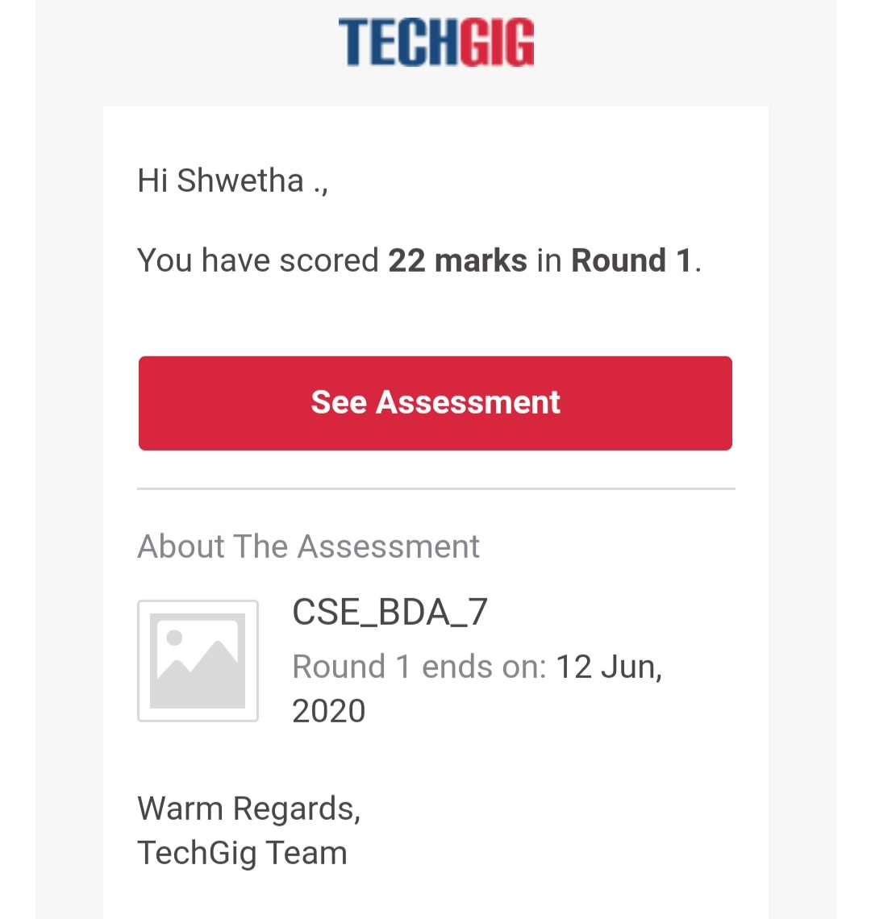

Certification Course Details:

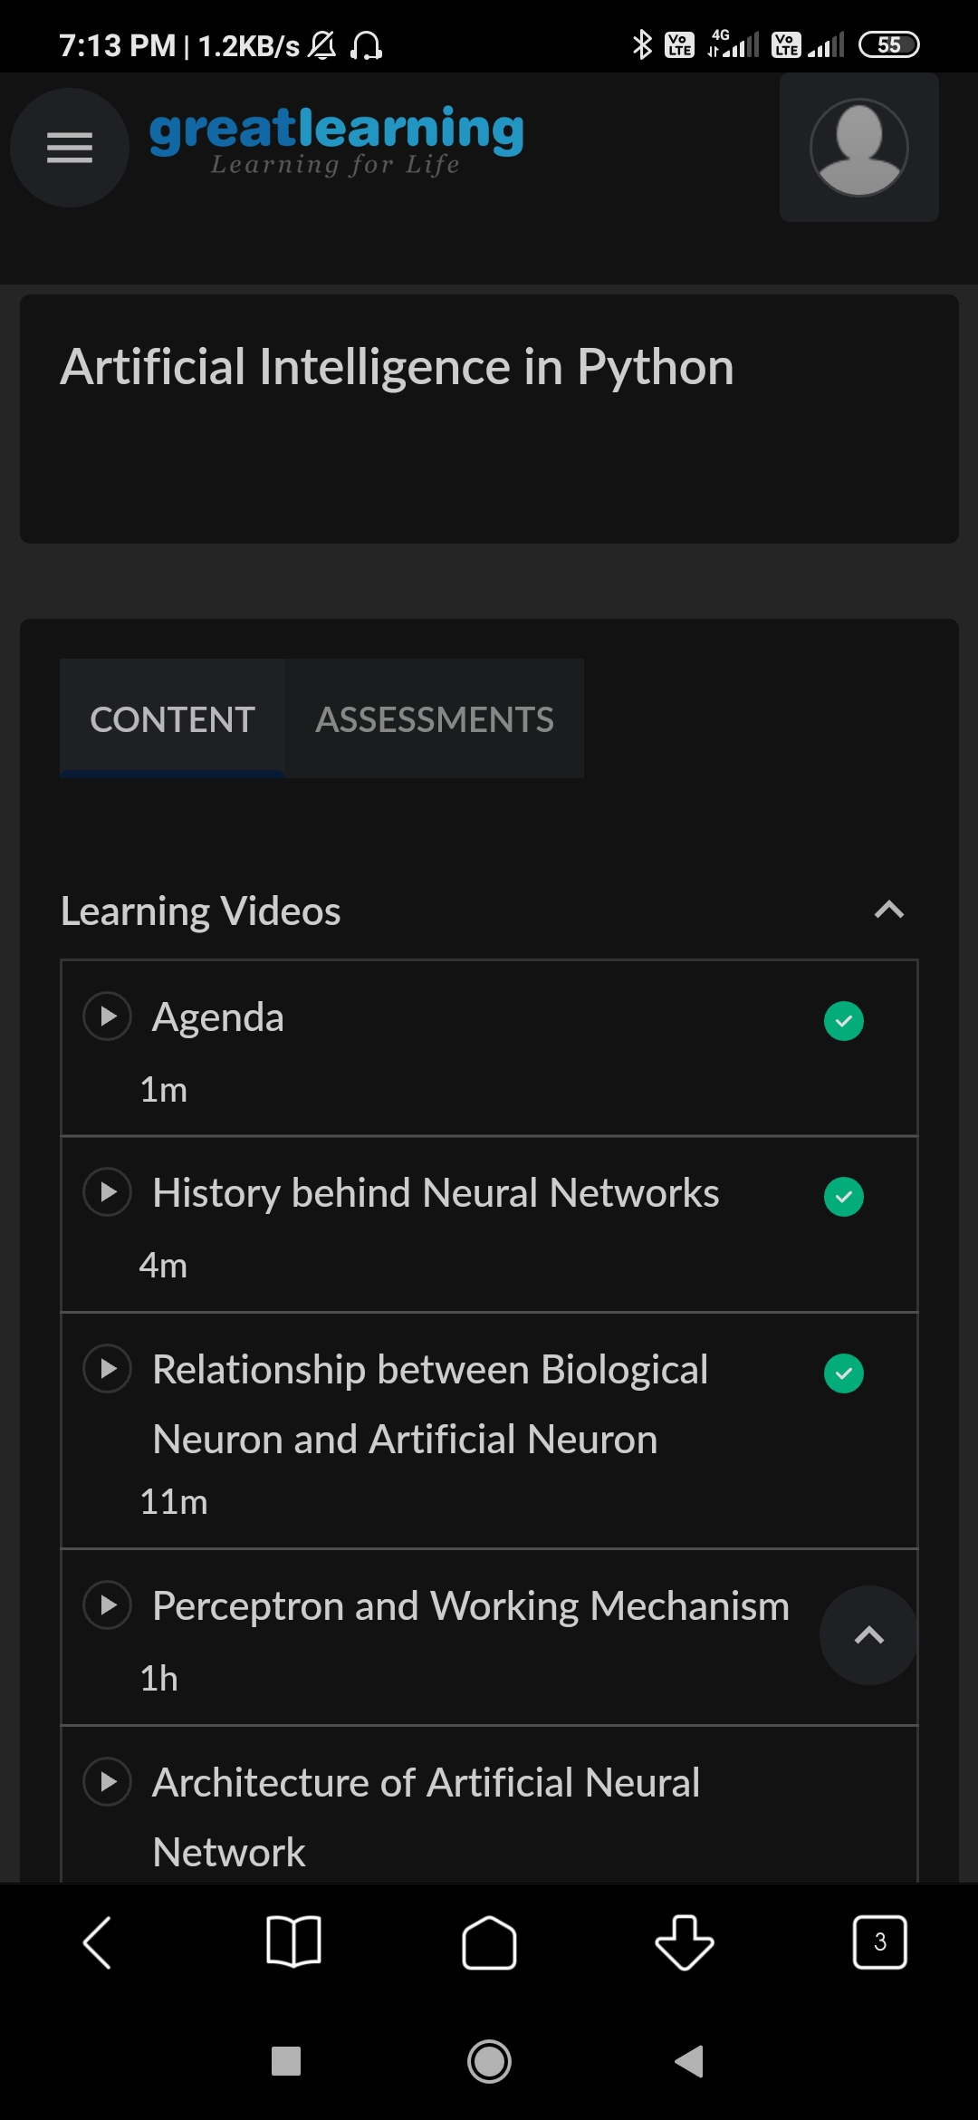

*Coding Challenges Details:*

defreverse_string_words(text):

forlineintext.split('\n'):

return(''.join(line.split()[::-1]))

print(reverse_string_words("Thequickbrownfoxjumpsoverthelazydog."))

print(reverse_string_words("PythonExercises."))